
Company
Logotype

Cone Beam Computed Tomography- Report



Porur Dental X-rays & CBCT

Patient Name : Mr. Ravi Rajasekar | Date of Report : 16.09.2024
Age/ Gender : 57 years/ Male | Region of Interest : CBCT Full Skull
Referring doctor: Dr. Dilip Kumar | Indication : Implant assessment
Clinical Notes: Nil
PATIENT INFORMATION

CBCT- Full Skull provided
CBCT – IMAGE DETAILS

RADIOGRAPHIC INTERPRETATION

- Completely edentulous maxillary and mandibular arch.
- The alveolar ridge in relation to the maxillary and mandibular alveolar ridge is present with resorptive changes leading to reduced height of the mandibular ridges.

IMPLANT ASSESSMENT

 | 11 region | 12 region | 13 region | 14 region | 21 region | 22 region | 23 region | 24 region
Sub-Crestal | 1.7 | 2 | 2.7 | 3 | 2.2 | 1.8 | 1.2 | 2.5
Mid- Crestal | 2.7 | 3.2 | 4.3 | 4.1 | 3.9 | - | 2.3 | -
Distance between the alveolar ridge and Floor of the Nasal cavity (in mm) | 6.7 | 10.3 | 12.4 | 10.6 | 8.1 | 4.2 | 6.2 | 6.2

 | 15 region | 16 region | 17 region | 25 region | 26 region | 27 region
Sub-Crestal (in mm) | - | - | - | 2.7 | - | -
Mid- Crestal (in mm) | - | - | - | 3.4 | - | -
Distance between the alveolar ridge and floor of the maxillary sinus (in mm) | 1.3 | 0.9 | 1.2 | 3.7 | 1.6 | 0.5

 | 31 region | 32 region | 33 region | 34 region
Sub-Crestal (in mm) | 3.2 | 2.6 | 2.9 | 3.4
Mid- Crestal (in mm) | 3.9 | 3.8 | 3.7 | 4.5
Distance between alveolar ridge and the inferior border of mandible (in mm) | 18.9 | 19.4 | 20.1 | 19.3

 | 41 region | 42 region | 43 region | 44 region
Sub-Crestal (in mm) | 3 | 2.8 | 4.1 | 5.4
Mid- Crestal (in mm) | 3.2 | 3.4 | 4.8 | 5.9
Distance between alveolar ridge and the inferior border of mandible (in mm) | 19.4 | 18.1 | 17.2 | 15
 | 45 region | 46 region | 47 region
Sub-Crestal (in mm) | 7.5 | 6.3 | 9.7
Mid- Crestal (in mm) | 8.4 | 9.1 | 10.5
Distance between alveolar ridge and the inferior alveolar nerve canal (in mm) | 5.4 | 4.9 | 6.2
Distance between alveolar ridge and the inferior border of mandible (in mm) | 15.8 | 13.4 | 15.3

 | 35 region | 36 region | 37 region
Sub-Crestal (in mm) | 3.4 | 4.1 | 3.3
Mid- Crestal (in mm) | 4.8 | 5.9 | 5.3
Distance between alveolar ridge and the inferior alveolar nerve canal (in mm) | 7.4 | 8.1 | 5.4
Distance between alveolar ridge and the inferior border of mandible (in mm) | 18.1 | 16.9 | 17

RADIOGRAPHIC IMPRESSION

- Completely edentulous maxillary and mandibular arch.

Kindly correlate with clinical findings


IMAGES FOR REFERENCE

RECONSTRUCTED PANORAMIC VIEW

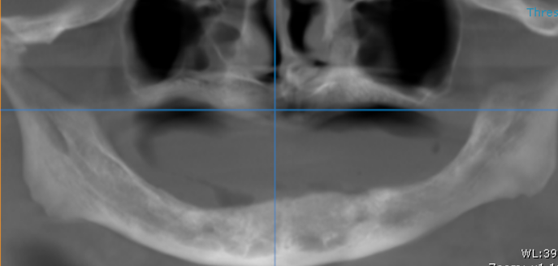

3-DIMENSIONAL VIEW

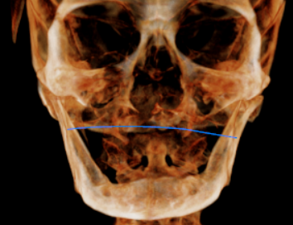

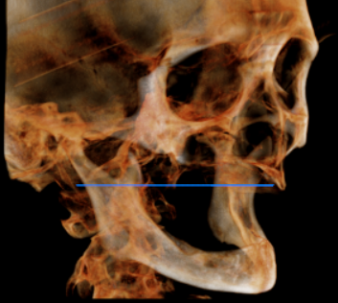
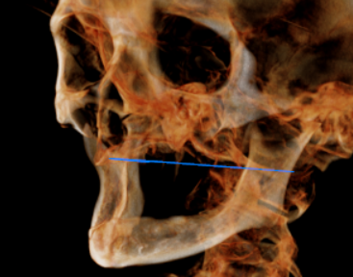

CROSS SECTIONAL VIEW

11 region | 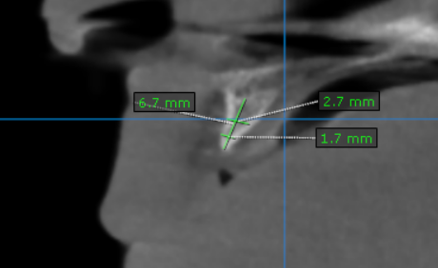
12 region | 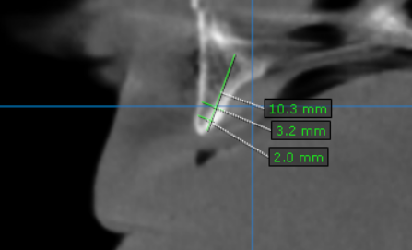
13 region | 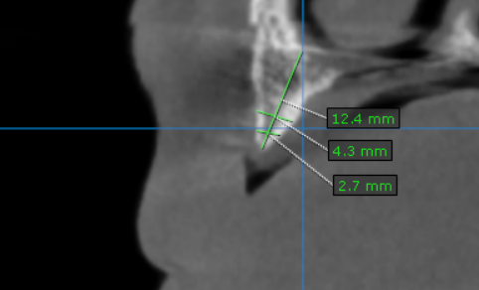
14 region | 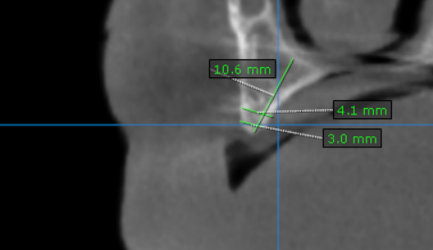
15 region | 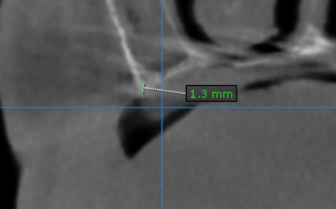
16 region | 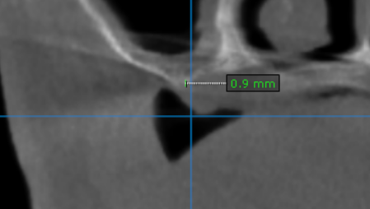
17 region | 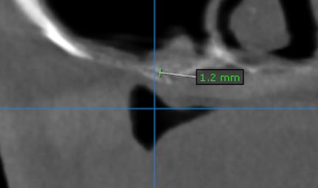
21 region | 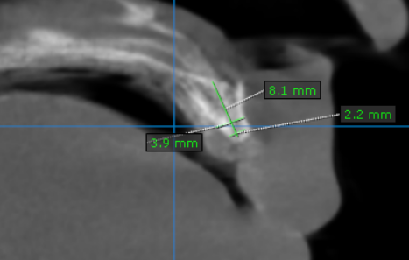
22 region | 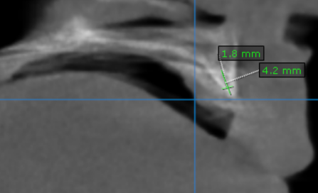
23 region | 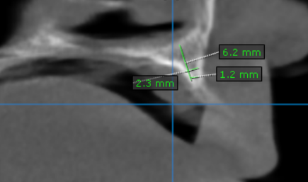
24 region | 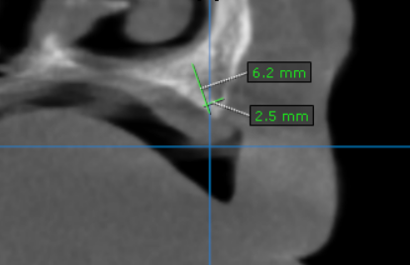
25 region | 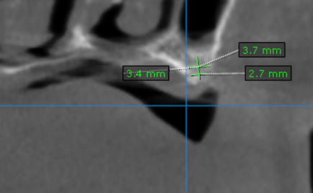
26 region | 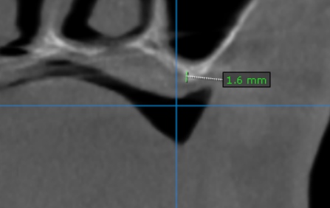
27 region | 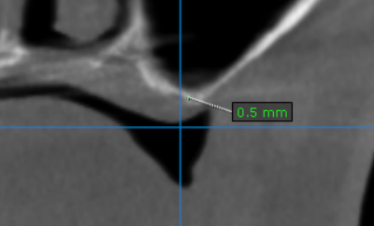
31 region | 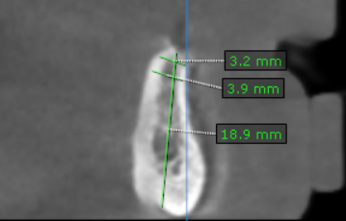
32 region | 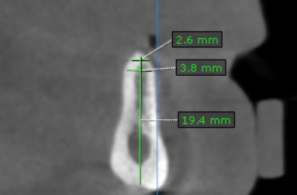
33 region | 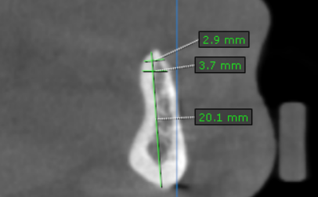
34 region | 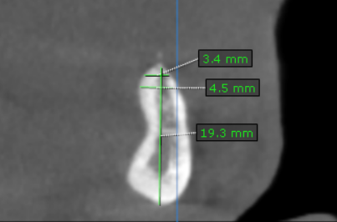
35 region | 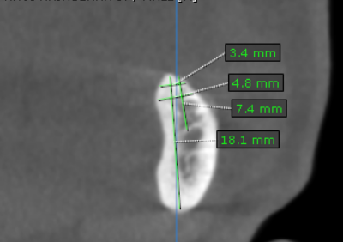
36 region | 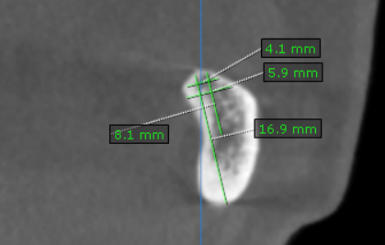
37 region | 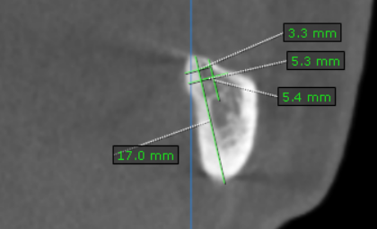
41 region | 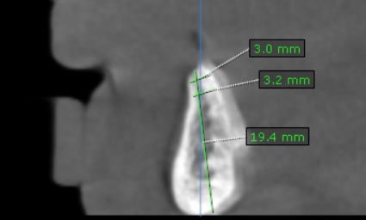
42 region | 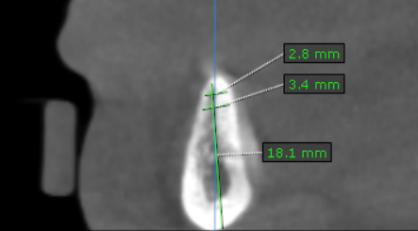
43 region | 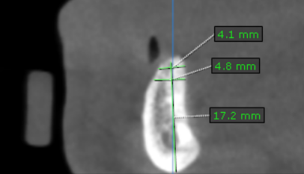
44 region | 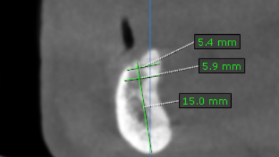
45 region | 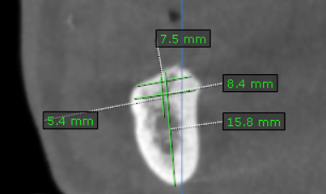
46 region | 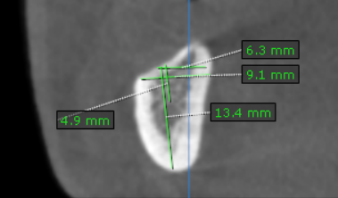
47 region | 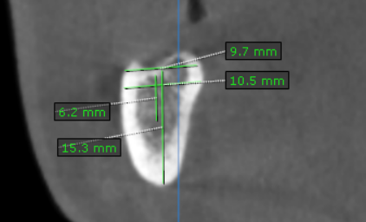

**** End of report ****

